Tables in FLEx

September 14, 2022  
Ken Zook

Contents

Tables in FLEx 1

1 Introduction 1

2 Table specifications 2

3 Sample tables 3

4 Customizing table styles 4

5 Importing tables from SFM 5

6 Importing tables from LIFT 6

7 Exporting tables to Webonary 6

# Introduction

Some dictionaries include small tables within entries that list related entries based on some criteria. Here are just a few tables from the Batad Ifugao Dictionary by Len Newell.

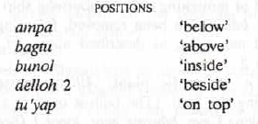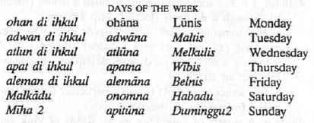

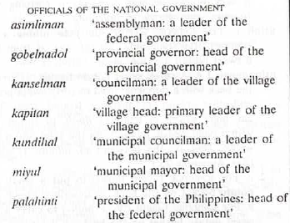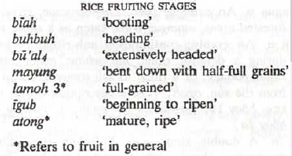

Starting in version 9.1.5, FLEx provides a way to add simple tables to entries or senses. The tables are structured similar to tables in Paratext. These tables can have a heading, and multiple columns with optional column headers, and rows. Cells can be left, centered, or right-aligned in the table. Character formatting can be applied through styles. Tables do not support data that wraps within a cell (so the 3rd table above would not be possible due to wrapping in a cell). At this point they do not provide links to jump to other entries.

# Table specifications

A table can be specified in any entry or sense custom Single-line Text field that uses First Analysis Writing System or First Vernacular Writing System. The table is specified in the custom field using standard format backslash codes to break the columns and rows. Shift+Return can be used to force new lines to make it a little easier to see the table structure in the data entry field. The formatted table will be displayed in the preview window, the dictionary views, and can be exported to Webonary.

Here is a simple example as it would look in the FLEx preview and data entry screen.

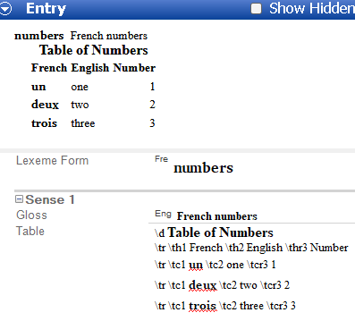

Any custom field that starts with \d or \tr will be treated as a table. The following backslash codes are available for specifying table data. The # is an optional column number. It is available in the data entry view to help identify the columns. The numbers are ignored when displaying the table. Multiple tables can be added to a single custom field by starting over with an additional \d.

|  |  |
| --- | --- |
| \d | Descriptive title starting a new table (leave field blank for no title) |
| \tr | Begin a new row |
| \thl# | Start a table header cell (bold and left-aligned) |
| \th# | Start a table header cell (bold and centered) |
| \thr# | Start a table header cell (bold and right aligned) |
| \tc# | Start a table cell (regular content, left aligned) |
| \tcc# | Start a table cell (regular content, center aligned) |
| \tcr# | Start a table cell (regular content, right aligned) |

# Sample tables

The first thing we need to do is create a custom field to hold the table in a sense. To do this, go to Tools…Configure…Custom Fields, click Add, give it a field name, such as “English Table”. In this case I use English to be the first analysis writing system which is the writing system used in most of the table. I also assume that French is the vernacular writing system in the project. Choose Sense as the Location, Single-line Text as the Type, and First Analysis Writing System for the Writing System, then click OK.

After creating an entry and filling in some basic information, we can then type the table content using backslash codes in the English Table field. But first, we need to check “Show Hidden Fields” to be able to see the English Table field. Then we can type the data for the table into this field. When typing, use a Shift+Return (U+2028) at the end of each line so that the table will be more readable in data entry. It should look like this.

\d Table of Numbers  
\tr \th1 French \th2 English \th3 Number  
\tr \tc1 un \tc2 one \tc3 1  
\tr \tc1 deux \tc2 two \tc3 2  
\tr \tc1 dix \tc2 ten \tc3 10

In order to see the table in the dictionary preview, we need to enable the field in Dictionary Configuration. You can get to this by right-clicking the entry in the dictionary preview and choosing Configure Dictionary View. By default, this table will look like this:

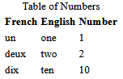

Note that all three columns are left-aligned and the size of the columns is based on the content in the cells. Cell content never wraps to a new line. The \d title is centered. The \th column headers are bold and centered in the column.

One improvement would be to right-align the right column. To do that, change \tc3 to \tcr3. Now it looks like this:

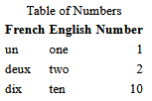

It would be nice to have the title larger and bold. We can use regular or custom styles to change the appearance of text in the table. (If you just created the custom field, you may need to stop and restart FLEx for FLEx to allow you to set styles and writing systems in the custom field.) One option for the title is to highlight the title, then in the Style combo choose “Title Secondary”. This makes the title larger, but not bold. We could modify the “Title Secondary” style, but it may be better to create a new “Table Title” style.

To create a style, use Format…Styles, choose “Add Character Style”, then change the Name to Table Title. Click the Font tab and choose the font for the title and set the size and check Bold, and close the dialog. Now highlight the title and select Table Title from the Style combo.

It would also be nice to have the French words bold, and they also should be set to French. We can do this by highlighting each French word in the table, then use the Writing System Combo to set it to French, and use the Style Combo to select the Strong style.

Now we have a table that looks reasonable.

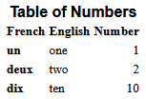

# Customizing table styles

In some situations, it may be desirable to change the styles of tables. This cannot be done in the FLEx UI, but can be done using style overrides, if you have some knowledge of CSS style sheets. It is not possible to have different styles for different tables in the same project, but you can modify the style for all tables, but it involves editing an XML style sheet. FLEx allows you to customize the stylesheet by adding style rules or overrides in an override file in the project folder.

In your project folder, go to ConfigurationSettings\Dictionary and open ProjectDictionaryOverrides.css in a text editor, such as Notepad++ or ZEdit. ZEdit is a simple text editor that is installed in c:\Program Files\SIL\FieldWorks 9. You can open it by clicking the Windows Start icon and typing Zedit and pressing Enter.

The following HTML CSS table styles (see <https://www.w3schools.com/Css/css_table.asp>) can be added to the overrides.css file to modify features of the table.

|  |  |
| --- | --- |
| table | gives control over the table layout including borders, size, color, etc. |
| caption | gives control over the table title size, font color, etc. |
| tr | gives control over the table row border, color, etc. |
| th | gives control over the column headers borders, color, etc. |
| td | gives control over normal cells borders, colors, etc. |

If you add these style rules to the file,

table {  
 border-collapse: collapse;  
}  
th, td {  
 border: 1px solid;  
}

then press F5 to refresh FLEx the table would look like this:

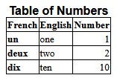

Using the following styles would widen the table to the size available with extra padding around cell content and adding a yellow background.

table {

border-collapse: collapse;

width: 100%;

}

th, td {

border: 1px solid;

padding: 6px;

background-color: yellow;

}  
th {

font-size: 120%;

}

Here’s the resulting table

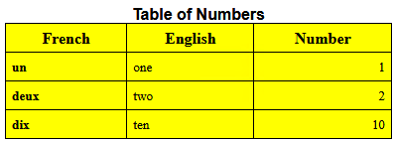

# Importing tables from SFM

The sample we’ve been looking at could be imported from SFM using this format.

\tb  
 \d |hTable of Numbers|r  
 \tr \th1 French \th2 English \th3 Number   
 \tr \tc1 |vun|r \tc2 one \tcr3 1  
 \tr \tc1 |vdeux|r \tc2 two \tcr3 2  
 \tr \tc1 |vdix|r \tc2 ten \tcr3 10

You’ll notice there is a U+2028 code at the beginning of each line of the table. This makes it format nicely in data entry and also keeps the backslash codes from being interpreted as SFM codes for the import. Inline markers can be used for styles and languages. In this case, in the Import setup,  
\tb would be mapped to the English Table custom field in English

|h…|r would be mapped to the Table Title style

|v…|r would be mapped to vernacular writing system and Strong style.

# Importing tables from LIFT

In a LIFT file, the sample we’ve been looking at would be like this.

<field type="English Table">

<form lang="en"><text>\d <span class="Table Title">Table of Numbers</span>

\tr \th1 French \th2 English \th3 Number

\tr \tc1 <span lang="fr" class="Strong">un</span> \tc2 one \tcr3 1

\tr \tc1 <span lang="fr" class="Strong">deux</span> \tc2 two \tcr3 2

\tr \tc1 <span lang="fr" class="Strong">dix</span> \tc2 ten \tcr3 10</text></form>

</field>

This includes the standard format markera and spans designating the writing system and style for each cell content. Instead of U+2028 for Shift+Return, the XML file simply uses a <CR><LF>. The field type is the custom field name.

# Exporting tables to Webonary

When we upload our table to Webonary, it looks like this:

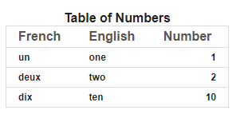

Webonary has some built in styles that may not be what you want. It is possible for the owner of the project site to add some limited customizations to adjust the final results. This is done using CSS style overrides in Wedonary.

To make adjustments for Webonary, log into your Webonary using the wp-admin URL. Click the Appearance menu on the left, then click the Customize button around the bottom left of the display. Then click the Additional CSS menu on the left. In the edit box at the bottom left, you can add CSS styles similar to those discussed in section ‎4. Here are some changes we could paste into this window to remove the border lines.

.pageentry tr td {

border-top: none;

}

.pageentry table {

border: none;

}

When done editing, click the Publish button at the top to make it live. Then you can refresh your browser showing your website to see the results. Here’s how it looks at this point.

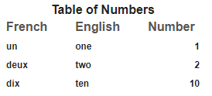

You may need to use the F12 developer mode in your browser to see the actual style names to override. Because of the order various styles are applied in the website, it’s not always possible to control what you would like. For example, the column headers are the same size as the table title, which is undesirable. Also, the bolding on the French column is being ignored. At one point I was able to control this using the site overrides. At this point it’s not working.